|  |  |
| --- | --- |
|  | ASSIGNMENT 1 |
|  |  |
|  | **ANDREW ID: parmenin**  18-788: Big Data Science  3/25/23 |

**Niyomwungeri Parmenide ISHIMWE**

----------------------------------------------------------------------------------------------------------------

I, the undersigned, have read the entire contents of the syllabus for course 18-788 (Big Data

Science) and agree with the terms and conditions of participating in this course, including

adherence to CMU's AIV policy.

Signature: **Niyomwungeri Parmenide ISHIMWE**

Andrew ID: **parmenin**

Full Name: **Niyomwungeri Parmenide ISHIMWE**

**LIBRARIES USED**

* import numpy as np
* import pandas as pd
* import matplotlib.pyplot as plt
* import warnings
* # %pip install haversine
* from haversine import haversine
* from scipy.optimize import curve_fit
* from sklearn.metrics import r2_score
* from sklearn.metrics import mean_squared_error
* from sklearn.model_selection import train_test_split
* from sklearn.neighbors import KNeighborsRegressor
* from sklearn.tree import DecisionTreeRegressor
* warnings.filterwarnings("ignore")

**QUESTION 1:**

It was asked to load into the environment (Jupyter notebook), the two historical monthly datasets (RwandaDistrictRainfall.csv and RwandaDistrictVegetation.csv) for each of the thirty districts in Rwanda. The data they offer includes measurements of rainfall and enhanced vegetation index, which are derived from data obtained through satellite imaging. This was done by downloading them and using the pandas’ read_cv function[1] to read from them.

**QUESTION 2:**

It was now required to graph two, time series for both rainfall and vegetation index with 6x5 subplots each for all the districts. Preprocessing the data frame was done by first transposing it, and inserting the date range to it to ease the plotting of the time. Next, the subplots were plotted for both rainfall and vegetation using the matplotlib.pyplot’s subplots function[2] for plotting and subplots_adjust[3] for adding margins to the plot and the following two graphs were produced.

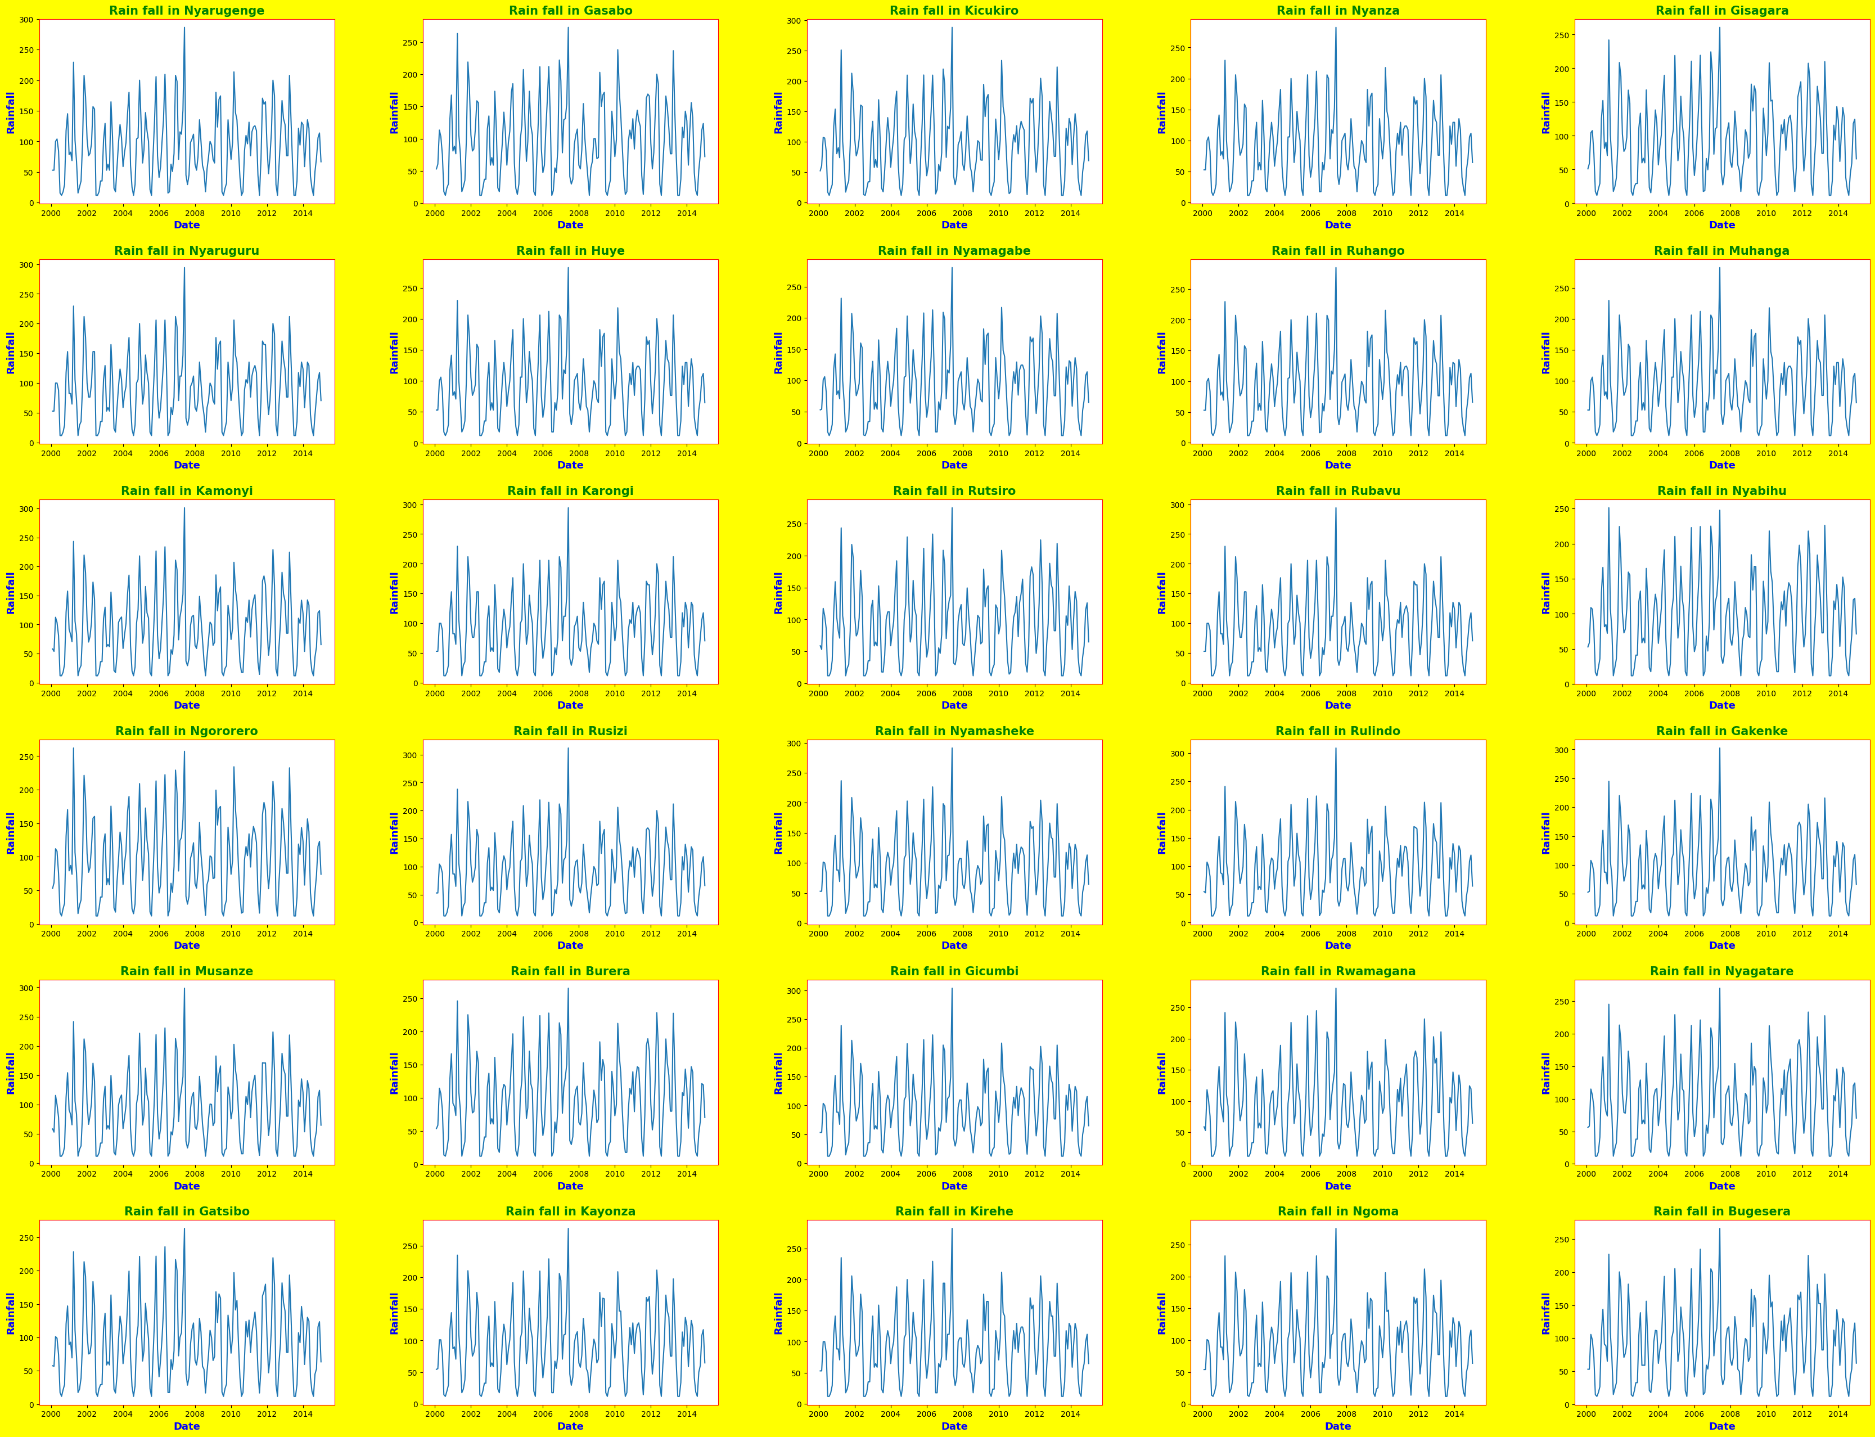

**Figure 1: The subplots for rainfall in 30 districts**

We can infer from the graph that the highest quantity of rain had fallen first, in 2007 and second, in 2001 in most of the districts of the country.

**Figure 2: The subplots for vegetation index in 30 districts**

We can infer from the graph that, as the highest quantity of rain had fallen first, in 2007 and second, in 2001 in most of the districts of the country caused the vegetation index to go high in 2001 and 2002 as well, even though the lowest quantity of vegetation index was found in the year 2001 for the most of the districts.

**QUESTION 3:**

It was required to calculate the mean, median, minimum, and maximum of both the rain fall and vegetation index for each month of the year, i.e., 12 monthly values and to plot them against the month of the year. These were calculated and stored inside the following data frame and plotted as of below.

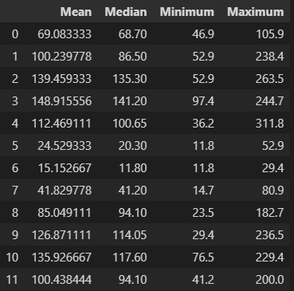

**Figure 3: The mean, median, minimum, and maximum data frame for rainfall**

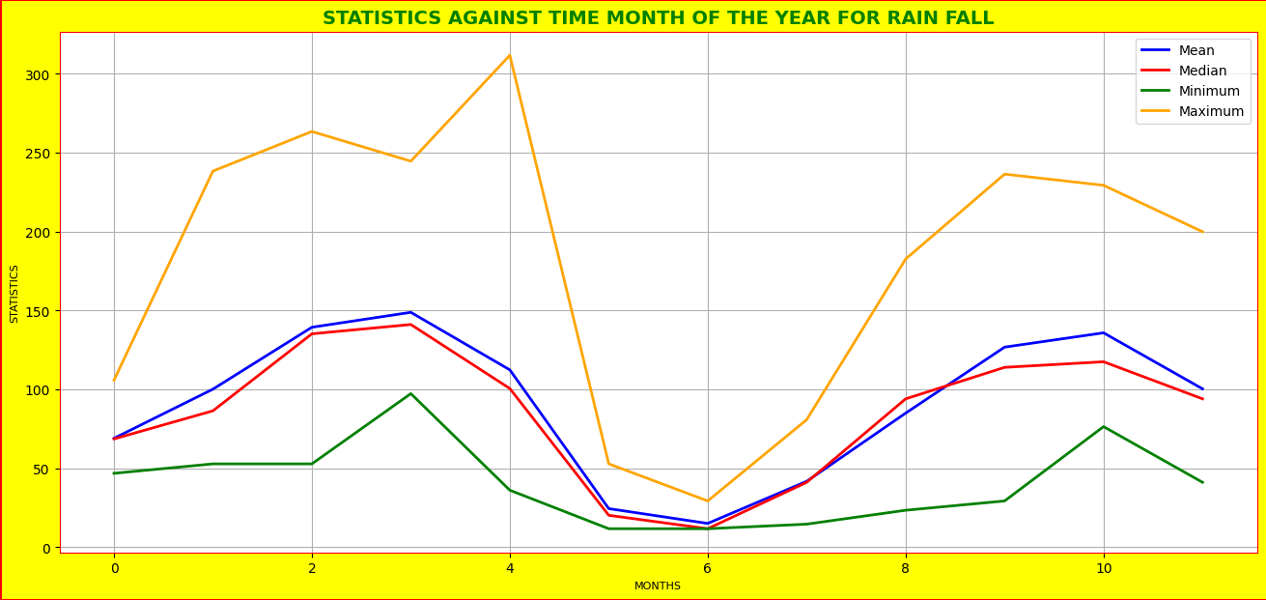

**Figure 4: The mean, median, minimum, and maximum graph for rainfall**

We can infer from the above plot and data frame that the low precipitation in Rwanda is seen in the month of July and the highest rainfall is seen in the month of April.

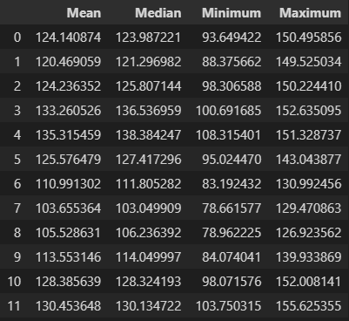

**Figure 3: The mean, median, minimum, and maximum data frame for vegetation index**

**Figure 4: The mean, median, minimum, and maximum graph for vegetation index**

From the above data frame and graph we can infer that the low vegetation index in Rwanda is seen in the month of August and the highest vegetation index is seen in the month of May.

**QUESTION 4:**

It is needed to compute the correlation coefficient (C) for rainfall between all pairs of districts and create a graph that shows the correlation against distance in kilometers. The graph should use the C(d) = C0exp(-ad) model to fit the data and plot a curve that illustrates the decline in correlation with distance. Finally, we needed to estimate the values of C0 and the decay constant (a) for the model.

This was done by first, loading the “RwandaDistrictCentroidsLongitude_Latitude.csv” data set, calculating the correlation coefficient **C** for rainfall between each pair of districts, computing the distance **d** between the pair. This was performed by the help of the haversine library which calculate the great-circle distance between two points on the Earth surface[4] and found to be **34.693078998302425 km**. After that, the following graph is made to show the correlation values versus the distance.

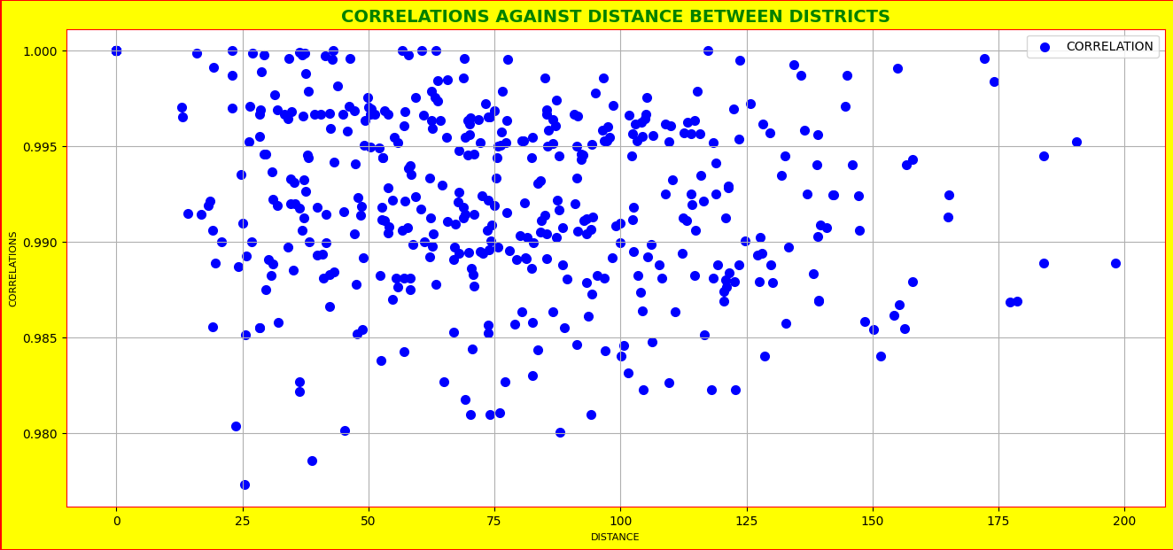

**Figure 5: The graph to show the correlation values versus the distance.**

Next, the model **C(d) = C0exp(-ad)** is fit, and the **curve_fit**[5] function is fit to the model, distances and correlations to provide the params (**C0)** and the decay constant (**a)** are estimated and they are **0.9949362375041936** and **3.234477915376383e-05** respectively.

Finally, this curve is plotted below to show how quickly the correlation declines with distance.

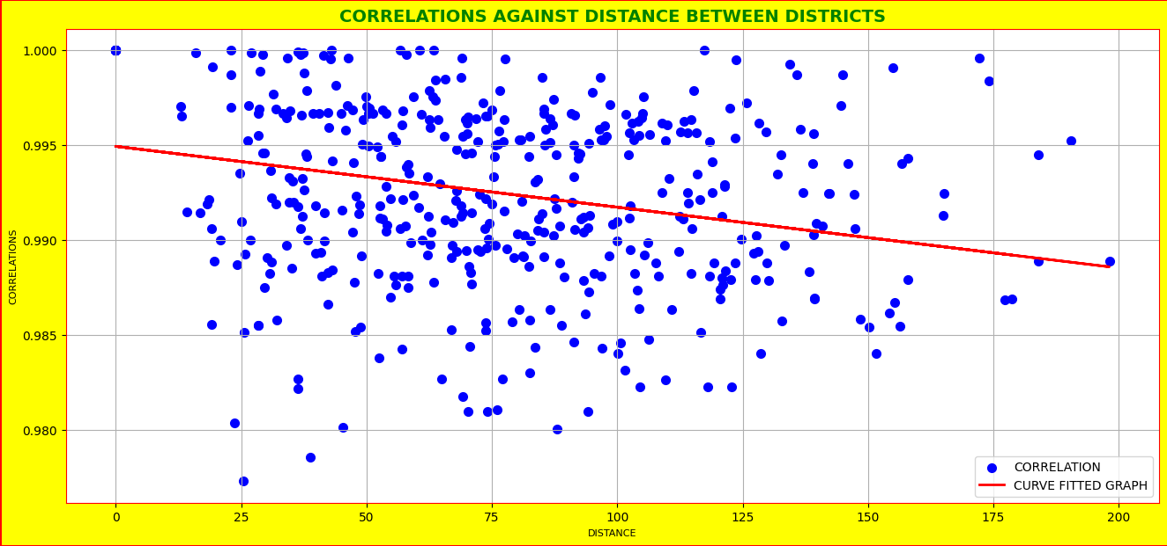

**Figure 6: The graph to show how quickly the correlation declines with distance**

From the graph, we may deduce that the more remote the districts are from one another, the less their data are correlated, and the closer the districts are to one another, the more correlated their data are.

**QUESTION 5:**

For this question, it was required to synchronize the dates for both rainfall and vegetation index and make a scatter plot for the same months and use colors and symbols to create a legend for the graph. This was done by first dropping the first four rows in the rainfall data set to match the shape with vegetation index. Then synchronizing the dates by making the date column as the index. After that, the following labelled plot is sketched show the vegetation index against rainfall.

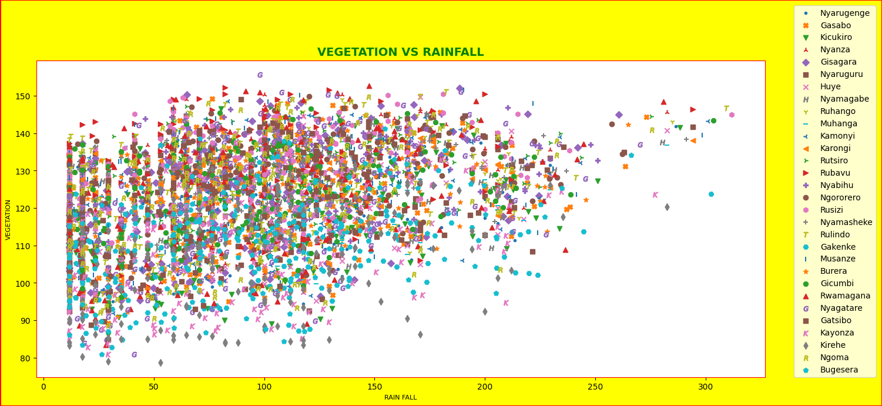

**Figure 7: The graph for vegetation index against rainfall**

We can infer from the graph that there is a strong correlation between rainfall and vegetation.

**QUESTION 6:**

As the optimal K is 1, therefore the rainfall has a considerable effect on vegetation after one month.

**QUESTION 7:**

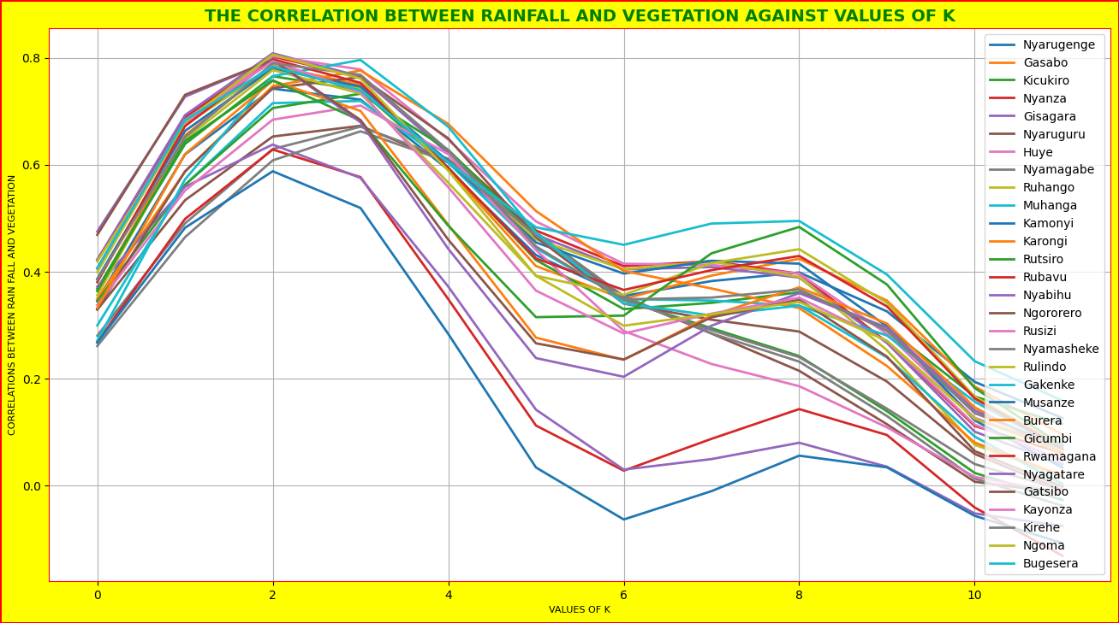

**Figure 8: The correlation vs values of k**

The value of K that gives the highest correlation is 2 because it has repeated many times.

**QUESTION 8:**

**Figure 9: The r squared table.**

**Figure 10: The adjusted r squared table.**

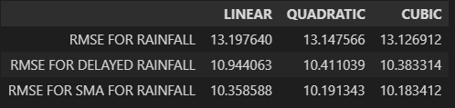

**Figure 11: The root mean squared error table.**

The best model is the cubic table as it has low errors and has larger r square and adjusted r squared scores.

**QUESTION 9:**

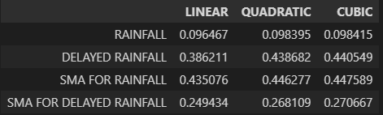

**Figure 12: The r squared table.**

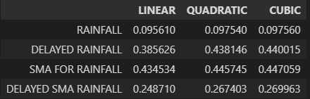

**Figure 13: The adjusted r squared table.**

**Figure 14: The root mean squared error table.**

We can infer from the above tables that the best model is the cubic model.

**QUESTION 10:**

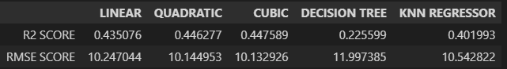

By looking to the above to table, we can infer that the cubic model is the best performing model as it has the lowest root mean squared error.

**Figure 15: Linear model for vegetation vs rainfall**

**Figure 16: Quadratic model for vegetation vs rainfall**

**Figure 17: Cubic model for vegetation vs rainfall**

**Figure 18: Decision tree model for vegetation vs rainfall**

**Figure 19: KNN model for vegetation vs rainfall**

**REFERENCES**

[1] ‘pandas.read_csv — pandas 1.5.3 documentation’. https://pandas.pydata.org/docs/reference/api/pandas.read_csv.html (accessed Mar. 25, 2023).

[2] ‘17. Creating Subplots in Matplotlib | Numerical Programming’. https://python-course.eu/numerical-programming/creating-subplots-in-matplotlib.php (accessed Mar. 25, 2023).

[3] ‘Matplotlib Subplots_adjust - Python Guides’, Sep. 16, 2021. https://pythonguides.com/matplotlib-subplots_adjust/ (accessed Mar. 25, 2023).

[4] ‘haversine: Calculate the distance between 2 points on Earth.’ Accessed: Mar. 25, 2023. [Online]. Available: https://github.com/mapado/haversine

[5] ‘scipy.optimize.curve_fit — SciPy v1.10.1 Manual’. https://docs.scipy.org/doc/scipy/reference/generated/scipy.optimize.curve_fit.html (accessed Mar. 25, 2023).